**Applications of Related Rates**

***Planetary motion***

The following represent a few facts about the Earth and the Sun. The orbit of the Earth is circular around the Sun. The period of the orbit of the Earth is one year. The radius of the orbit of the Earth about the Sun is 93 million miles.

Kepler’s third law of planetary motion states: For planets with circular orbits, the square of the orbital period is proportional to the cube of the radius of the circular orbit. Assuming the orbit of the Earth is circular about the Sun, if *T* is the period of the orbit of the Earth and *r* is the radius of the orbit the equation relating *T* and *r* is



In the equation, *G* is the universal gravitational constant and *M* is the mass of the Sun.

**Problem:** Find the formula for the rate of change of the period of the Earth’s orbit with respect to a change of radius.

**Solution:** In order to solve the problem, we need to find 



We note that the right hand side of equation (2) contains the term T. We can solve equation (1) to yield an expression for the variable T.



Next we can substitute the expression for T in equation (3) into equation (2) and simplify.



Thus we find that the rate of change of the period of the orbit with respect to change in the radius of the orbit is equal to the product of a physical constant and the square root of the radius of the orbit.

***Electomagnetic induction of a conducting loop spinning in a magnetic field***

Voltage can be induced by spinning a loop of wire located in a magnetic field. This effect was first observed many years ago by the scientist, Michael Faraday.

Figure 1 displays a picture of a loop of conducting material (*e.g*., copper wire) of area *A*, that is situated between the North and South poles of a magnet. The magnet sets up a constant magnetic field (B) that will be horizontally directed between the poles of the magnet.

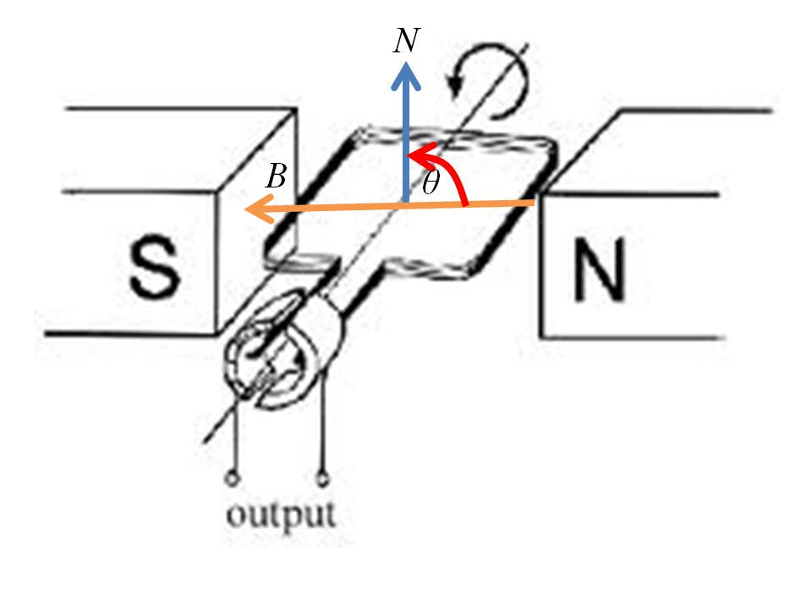

Let *N* represent a vector that is directed normal to the area inscribed by the loop. The magnetic flux Φ through the loop of area *A* whose normal is at an angle θ to the magnetic field *B* is given by the equation



Faraday’s law of electromagnetic induction states that the induced electromotive force (voltage) E is the negative rate of change of magnetic flux Φ through the conducting loop.

E 

Let us assume that the area of the conducting loop, *A*, and the strength of the magnetic field, *B*, are held constant. Now, suppose that the loop is rotated so that the angle θ is some known function of time, *t*. With these ideas in place, we can relate the rate of change of θ to the rate of change of Φ.

E 

Consider the case where the loop is rotating at a constant angular velocity, ω. Stated mathematically,



Therefore, the rate of change of θ with respect to time is a constant



We substitute the rate of change of θ expressed in equation (9) into the expression for the induced electromotive force shown in equation (7).

E 

We now substitute for the value of θ expressed in equation (8) into equation (10) to obtain the result

E 

This induced electromagnetic force takes the form of a voltage that appears at the output shown in the Figure. This example provides a glimpse into how electric power generators operate.